|  |  |
| --- | --- |
| Name : Heeranand | Lab 05 |
| Roll No: Ari-f23-0096 | Submitted To: Sir Abdul Ghafoor |

**TASK 01**

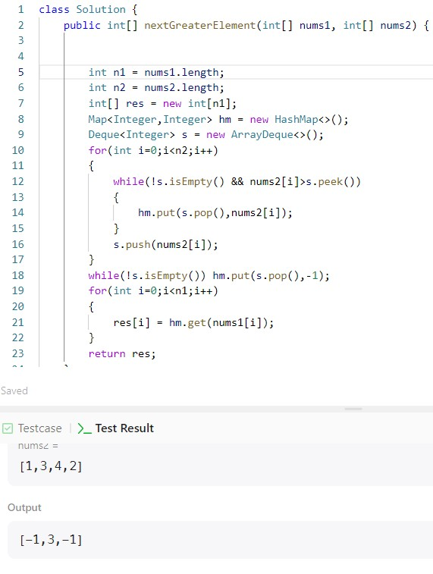

**TASK 02**

**TASK 03**

